**Ideation Phase**

**Empathize & Discover**

|  |  |
| --- | --- |
| Date | 31 January 2025 |
| Team ID | LTVIP2025TMID38625 |
| Project Name | revolutionizing liver care |
| Maximum Marks | 4 Marks |

**Empathy Map Canvas:**

## 🧠 ****What is an Empathy Map Canvas?****

An **Empathy Map Canvas** is a structured framework that captures what a person **says, thinks, does, and feels** in a specific context. In revolutionizing liver care, it is used to:

* Understand the **emotional and behavioral experience** of patients and stakeholders.
* Align team members around **real, human-centered problems**.
* Identify unmet needs that can lead to **transformative solutions**.

## 🎯 ****Why Use It in Liver Care?****

Liver diseases—like NAFLD, cirrhosis, or hepatitis—often progress **silently**, with low awareness among patients and even primary care providers. An empathy map helps uncover:

* Emotional responses to diagnosis and treatment
* Barriers in access, communication, and care continuity
* Misconceptions about liver health
* Caregiver challenges in post-transplant or chronic management

## 📌 ****Use Cases in Liver Care Innovation****

* Designing a **patient education app**
* Creating a **screening protocol in primary care**
* Improving **transplant patient aftercare**
* Developing **telehealth tools for remote patients**

## 🖼️ Empathy Map Canvas Template (Summary Layout)

| SAYS | THINKS |

|--------------|--------------|

| What they say| Inner voice |

| DOES | FEELS |

|--------------|--------------|

| Behavior | Emotions |

| PAINS |

|----------------------------|

| Frustrations, obstacles |

| GAINS |

|----------------------------|

**Example:**

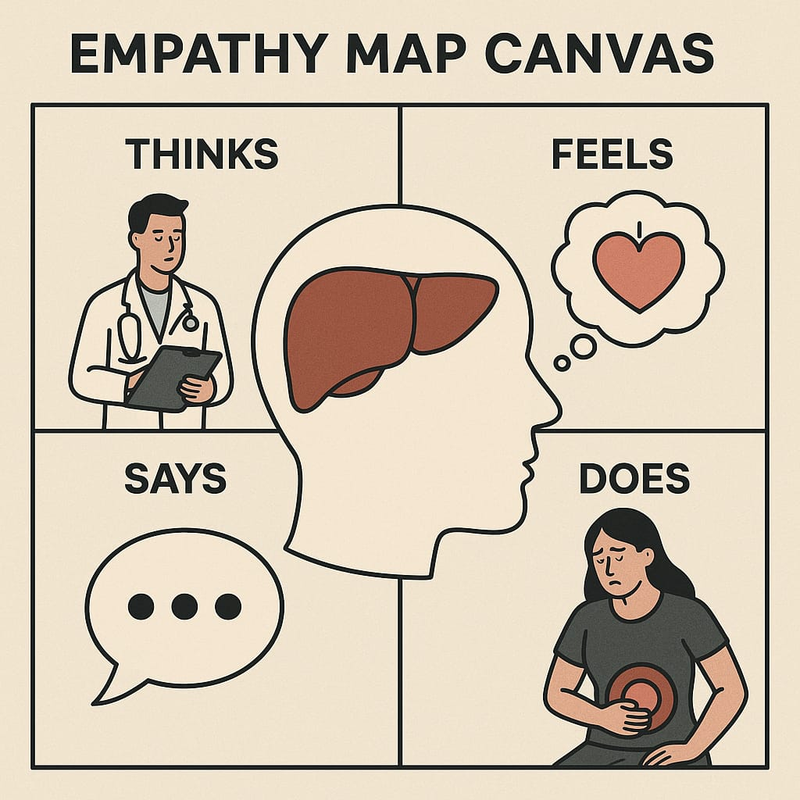

**Example: Food Ordering & Delivery Application:**

+------------------------+

| Patient/End User |

|(Mobile App Interface) |

+----------+-------------+

|

v

+---------------+---------------+

| Personalized Meal Planner |

| (Based on liver condition, |

| doctor/dietician input) |

+---------------+---------------+

|

v

+------------------+------------------+

| Doctor/Dietician Dashboard |

| - Set meal plans |

| - Track compliance |

| - Monitor nutrition reports |

+------------------+------------------+

|

v

+-------------------------------+

| Food Vendor Management |

| - Partnered liver-friendly |

| kitchens/restaurants |

| - Menu customization |

+----------------+---------------+

v

+------------+------------+

| Delivery Service API |

| - Route optimization |

| - Real-time tracking |

+------------+------------+

|

v

+----------+-----------+

| Feedback & Health |

| Monitoring System |

| - Rate meals |

| - Log symptoms |

| - Track improvements |

+----------------------+